A000-Mex-Olmec-Were Jaguar-Pendant-1200-900 BCE

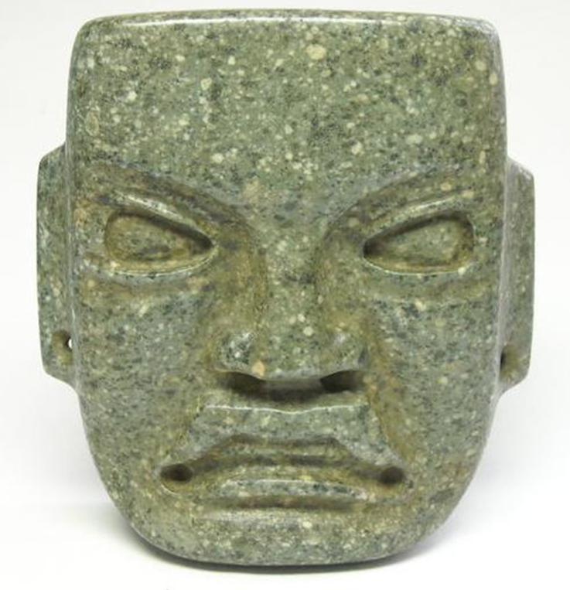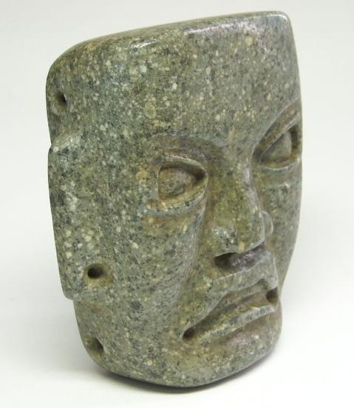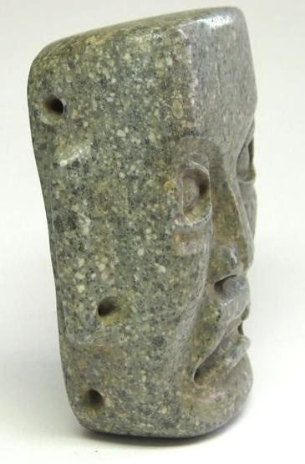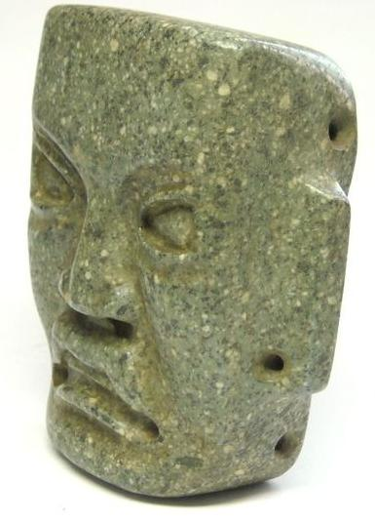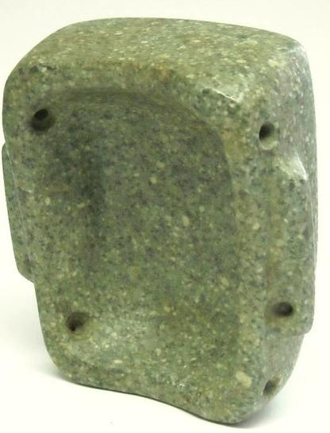

Formal Label: Olmec-Were Jaguar-Pendant-1200-900 BCE

Accession Number:

**LC Classification:**

**Display Description:**

Date or Time Horizon: 1200-900 BCE

Geographical Area: Cuautla, Morelos, Mexico

Cultural Affiliation: Olmec

Medium: Amphibolite

Dimensions:

Weight:

Condition: no defects

Provenance:

**Discussion:** This Olmec Were Jaguar pendant dates to the period 1200-900 BCE.

The mask is carved from grey-greenish amphibolite composed of amphibole dark colored prismatic crystals (with interlocking chains of silicate tetrahedra),and plagioclase feldspars. It is typically dark-colored and heavy, with small flecks of black and white giving it a salt-and-pepper appearance.

The mask features a rigidly rectilinear geometric portrait of a shaman being transformed into a jaguar spirit. He has a flared nose, up-curved upper lip which is intended to emulate the jaguar's snarl, as he bares a row of evenly filed teeth. Four holes, two drilled into the temples and two drilled into the cheeks, indicate that this was to be worn as a pendant on the chest and not as a mask, and this is confirmed since the eyes are not drilled. However, the pupils of the eyes have been expertly abraded to produce a visage at once powerful and terrifying as they gaze down on their on-looking subject. Two additional holes were drilled into the ear lobes to suspend earrings. A similar, rigidly rectangular maskette effigy plaque from Cuautla, Morelos, Mexico, is in the University of Maine Museum.